**LP SETUP ERRORS AND RESOLUTION**

**ERROR # 1:**

"Failed to start service 'Sitecore XConnect Search Indexer - xp0.xconnect-IndexWorker"

When installing SC9, we are getting this error. There seems to be a problem starting the indexe:

[--------------------------------------- StartServices [1] : ManageService -------------------------------------------]  
[StartServices [1]]:[Updating] xp0.xconnect-IndexWorker  
WARNING: Waiting for service 'Sitecore XConnect Search Indexer - xp0.xconnect-IndexWorker (xp0.xconnect-IndexWorker)' to start...  
>> TerminatingError(Start-Service): "The running command stopped because the preference variable "ErrorActionPreference" or common parameter is set to Stop: Failed to start service 'Sitecore XConnect Search Indexer - xp0.xconnect-IndexWorker (xp0.xconnect-IndexWorker)'."  
>> TerminatingError(Start-Service): "The running command stopped because the preference variable "ErrorActionPreference" or common parameter is set to Stop: Failed to start service 'Sitecore XConnect Search Indexer - xp0.xconnect-IndexWorker (xp0.xconnect-IndexWorker)'."  
Install-SitecoreConfiguration : Failed to start service 'Sitecore XConnect Search Indexer - xp0.xconnect-IndexWorker  
(xp0.xconnect-IndexWorker)'.  
At C:\websites\Sitecore Files\9\SIFLess\SIFless-EZ-1510077556.ps1:42 char:1  
+ Install-SitecoreConfiguration @xconnectParams  
+ ~~~~~~~~~~~~~~~~~~~~~~~~~~~~~~~~~~~~~~~~~~~~~  
+ CategoryInfo : NotSpecified: (:) [Write-Error], WriteErrorException  
+ FullyQualifiedErrorId : Microsoft.PowerShell.Commands.WriteErrorException,Install-SitecoreConfiguration  
Install-SitecoreConfiguration : Failed to start service 'Sitecore XConnect Search Indexer - xp0.xconnect-IndexWorker  
(xp0.xconnect-IndexWorker)'.  
At C:\websites\Sitecore Files\9\SIFLess\SIFless-EZ-1510077556.ps1:42 char:1  
+ Install-SitecoreConfiguration @xconnectParams  
+ ~~~~~~~~~~~~~~~~~~~~~~~~~~~~~~~~~~~~~~~~~~~~~  
+ CategoryInfo : NotSpecified: (:) [Write-Error], WriteErrorException  
+ FullyQualifiedErrorId : Microsoft.PowerShell.Commands.WriteErrorException,Install-SitecoreConfiguration

**RESOLTUION for #1:**

The license is expired. The Setup can’t pull the license from Shared Resource. So manually copy the valid license file into **lib/sitecore/license** folder.

**ERROR #2:**

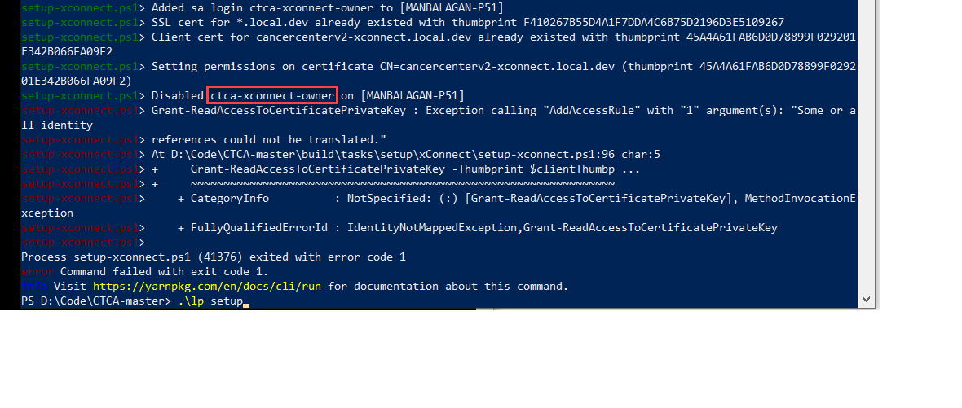

**Resolution for # 2:**

* **LP setup is looking for ‘CTCA-xConnect-Owner’, where as it should look for ‘CTCAv2-xConnect-Owner’**
* **The project name($ProjectName) needs to changed in ‘..\doc\Server Configuration Scripts\Solr Server\Solr Configuration.ps1**

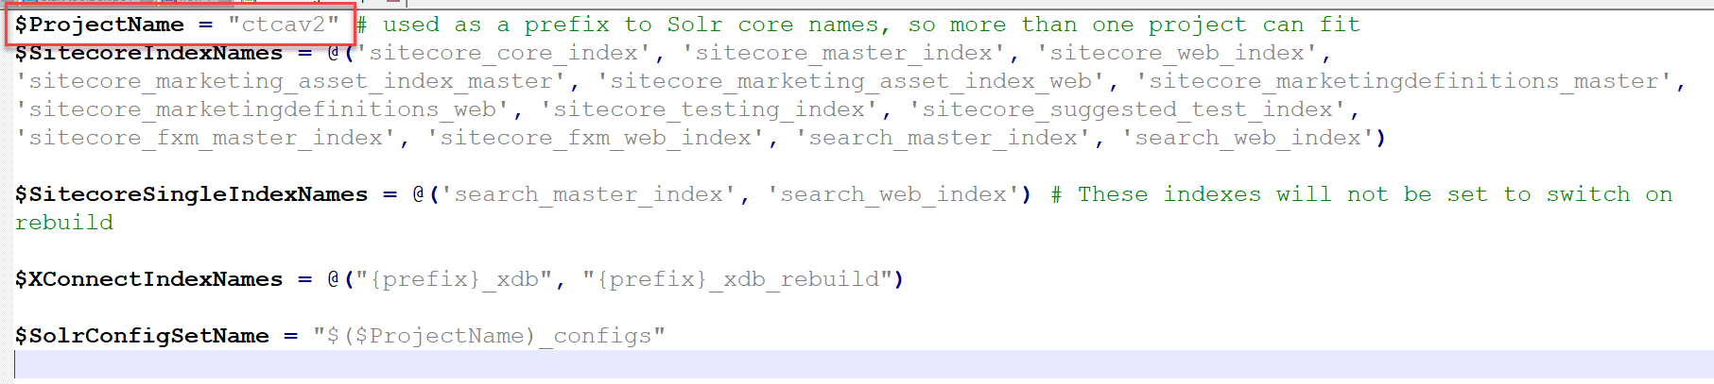

**ERROR # 3:**

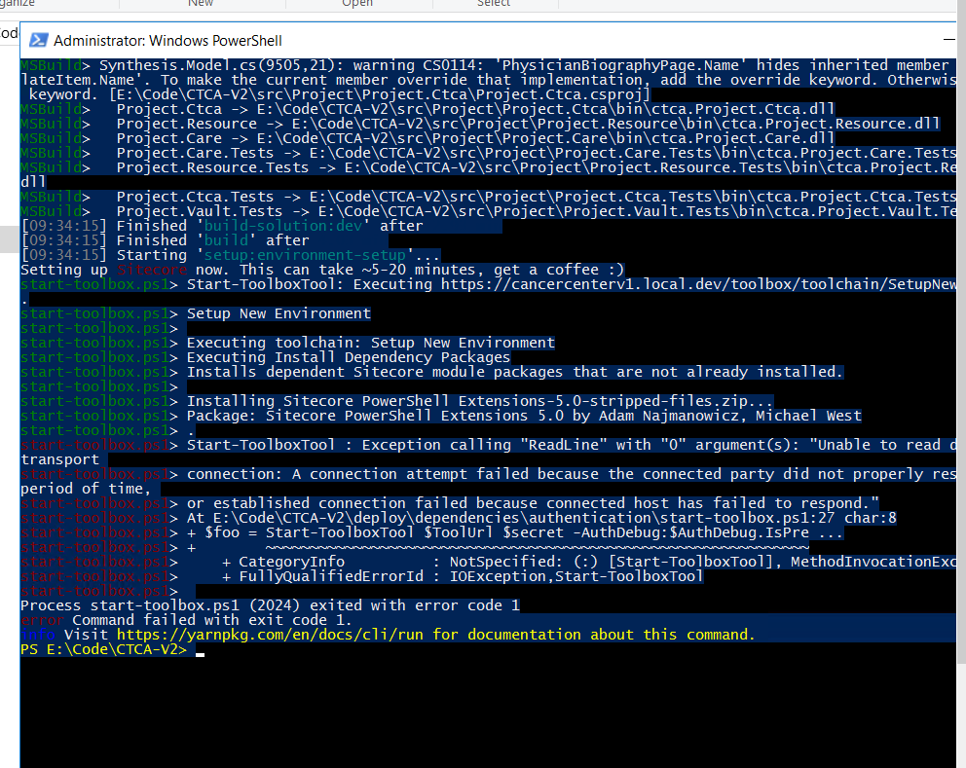

**Resolution for # 3:** When Toolbox times out, login to sitecore and navigate to toolbox. If it’s saying loading, go directly to ‘toolbox/toolchain/PostPull’ and it will sync unicorn files and publish items to web. This completes the LP Setup.